Flight Arrival
Time Change
Prediction
BY
Manasa Dontireddy

TABLE OF CONTENTS:
CHAPTER 1: INTRODUCTION 4
1.1 Objectives 5
1.2 Research Questions 5
CHAPTER 2: LITERATURE REVIEW 6
2.1 Research Gaps and Limitations 6
2.2 Contribution of This Study 7
CHAPTER 3: METHODOLOGY 7
3.1 Software and Tools 7
3.2 Data Collection 7
3.2.1 Dataset Overview 10
3.3 Data Filtering and Integration 10
3.4 Target Variables 13
3.5 Cleaning & Transforming Date and Time Columns 15
3.6 Weather Data — DFW Departure Airport (2021–2025) 15
3.6.1 Weather Distribution plots 17
3.6.2 Weather Correlation with Delay Targets 20
3.7 Data Cleaning 22
3.8 Feature Engineering 24
3.8.1 Removal of Identifier Columns 28
3.8.2 Data Preparation and Variance Filtering 28
3.8.3 Prevention of Data Leakage 28
3.8.4: Multicollinearity Check 29
CHAPTER 4: EXPLORATORY DATA ANALYSIS (EDA) 31
CHAPTER 5: MODELING 34
5.1 Temporal Train/Test/Validation Split 34
5.2 Classification Model 35
5.2.1 Classification models used 35
5.2.2 Classification Results –Testset 36
5.2.3 ROC Curve Comparison 37
5.2.4 Calibration Curve 39
5.2.5 CLASSIFICATION VALIDATION RESULTS (HELD OUT 10%) 39
5.2.6 CLASSIFICATION CONFUSION MATRIX 41
5.3 Regression Model 42
5.3.1 REGRESSION RESULTS – TEST SET 42
5.3.2 Regression Validation Results 43
5.3.3 Regression — Error Analysis 44
5.3.4 Regression — Actual vs. Predicted 45
5.3.5 Regression — Feature Importance 47
5.4 Hyperparameter Tuning and Final Model Optimization 48
5.4.1 XGBoost Classifier Tuning 48
5.4.2 Model Tuning Comparison – Before vs After Tuning 50
5.5 FINAL TUNED MODEL RESULTS 50
5.6 SHAP 51
CHAPTER 6: CONCLUSION 54
6.1 Limitations and Future Work 56
REFERENCES 56

CHAPTER 1: INTRODUCTION
Flight delays are among the most significant operational problems in the aviation industry, causing financial losses, poor resource utilization and discontent among passengers. Minor delays at a major airport like Dallas/Fort Worth International Airport (DFW), for instance, can ripple through the system, impacting thousands of flights down. Traditional delay analysis is mostly reactive, simply recognizing delays after they have happened. This limits the ability of airlines and airports to take proactive actions. Thus, it is more important than ever to be able to predict delays before departure from real-time operational signals and environment. Airlines and airports face delays in flight times as a constant challenge in the quest to efficient services in the world of air travel. Small changes to the flight operations can snowball into bigger operational inefficiencies, impacting everything from crew assignment to gate management and passenger service. Airports like Dallas/Fort Worth International Airport (DFW) receive thousands of flights each day and predicting delays is a critical element of airline operations.
Over the past few years, machine learning has advanced to the point where it can be used to predict operational disruptions based on data. Using past flight data and environmental factors, predictive models can recognize patterns that are difficult to see otherwise. These models enable the airline to take proactive decisions, decrease uncertainty and increase the reliability of the overall system.
This project aims at building a machine learning system to forecast flight delays based on operational flight data and historical weather data. In order to account for both internal and external factors that affect delays, the study combines ETA (Estimated Time of Arrival) operational data, airport scheduling data and weather data including wind speed, precipitation and temperature.
The problem is tackled in a two complementary tasks. The classification model is first developed to predict whether there is a delay or an on-time arrival for a flight. Second, a regression model is used to estimate in minutes how much time it takes for flights that are likely to be delayed. A two-stage modeling approach is used to offer both early warning and severity estimation for the system to be more actionable for real-world deployment.
This project will use the capabilities of large-scale datasets, feature engineering techniques, and powerful machine learning frameworks like XGBoost and LightGBM to create a system capable of predicting delays accurately and explainably. The result enables better decision-making by the airlines, better resource planning and improved passenger communication.

1.1 Objectives
1. Determine the presence of alternative/non-alternative of arrival time of a flight.
2. Rather than just pointing out possible delays, estimate the magnitude of the change.
3. Prediction needs to be improved by several past and current factors that are meant to increase accuracy and actionability.
By addressing this matter, the research would create a tool that would allow creating proactive decisions in its operations, reduce unnecessary disruptions, and improve the overall travel experience.

1.2 Research Questions
This study aims to address the following research questions, focusing on both predictive performance and operational relevance:
RQ1: Flight Delay Classification
Can a machine learning model accurately predict whether a flight departing from DFW Airport will be delayed or arrive on time using real-time ETD (Estimated Time of Departure) signals and historical weather data?
RQ2: Delay Duration Prediction
To what extent can the magnitude of arrival delay (in minutes) be predicted using operational and environmental features available at or near departure time?
RQ3: Impact of Weather Variables
Which weather-related factors (e.g., wind speed, precipitation, pressure, and humidity) have the strongest statistical relationship with flight delays, and how do they influence delay occurrence and duration?
RQ4: Model Generalizability
Can the developed machine learning models generalize effectively to future unseen flight data when trained using a temporally split dataset, avoiding data leakage and preserving real-world deployment conditions?

CHAPTER 2: LITERATURE REVIEW
The recent developments in aviation analytics have made flight delay prediction an important aspect that has been enhanced by using machine learning, big data, and real-time data sources. Conventional statistical methods tend to have a weak ability to capture the complex and dynamic characteristics of flight operations, which has contributed to the rise in the use of machine learning methods to enhance predictive effectiveness (Guan et al., 2020).
The machine learning models, including Logistic Regression, Random Forest, and ensemble-based methods, have been proven to be effective in forecasting flight delays in several studies. Indicatively, Khaksar and Sheikholeslami (2017) discovered that ensemble models are more accurate in classification than traditional methods. More sophisticated methods, such as deep learning methods have also improved the performance of prediction. Kim et al. (2016) presented a deep learning model to predict the delay, whereas Silvestre et al. (2024) proved the usefulness of Long Short-Term Memory (LSTM) models in identifying time-related variations in flight data.
Besides modeling methods, literature also determines major factors that affect delays in flights. Weather conditions, air traffic congestion and operational constraints are always identified to be major predictors. Choi et al. (2016) emphasized the great impact of the meteorological variables in prediction delay models.
There is also recent research on the necessity to combine several data sources. Wang et al. (2020) used trajectory-based information to predict ETA and Zheng et al. (2023) showed that real-time information can be used to improve prediction despite having limited inputs. These results underscore the increased role of integrating operational and real-time information in aviation analytics.

2.1 Research Gaps and Limitations
Despite significant advancements, several limitations exist in current research:
- Many studies rely on limited or single-source datasets, reducing model generalizability
- Lack of proper temporal validation, leading to overestimated performance
- Insufficient handling of data leakage and multicollinearity
- Limited focus on interpretability, especially in deep learning models
- Few studies combine classification and regression tasks in a unified framework
These gaps highlight the need for more robust, interpretable, and production-ready predictive systems.

2.2 Contribution of This Study
This project addresses the identified gaps by:
- Integrating large-scale ETA operational data with historical weather datasets
- Applying temporal train-test-validation splitting to avoid data leakage
- Performing feature engineering and selection to improve model robustness
- Implementing both classification and regression models for comprehensive prediction
- Using SHAP analysis to enhance interpretability of model predictions

CHAPTER 3: METHODOLOGY

3.1 Software and Tools
All data processing, analysis, and modeling were performed using Python. The primary tools and libraries include:
- Pandas, NumPy → data manipulation
- Matplotlib, Seaborn → visualization
- Scikit-learn → preprocessing and baseline models
- XGBoost, LightGBM → advanced machine learning models
These tools enabled efficient handling of large-scale flight and weather datasets.

3.2 Data Collection
This research combines various data sources to reflect both operational and environmental factors that impact flight delays:
Data in this study were provided by American Airlines. The ETA Change Prediction dataset, and Airport Information dataset, are included in the dataset they provided. Both datasets offer the airport infrastructure data and flight operational data, both of which can be analysed to look at how Estimated Time of Arrival (ETA) have varied since flight departure.
The ETA Change Prediction dataset has specific flight-level operational data that was gathered using airline flight tracking systems and operational management systems. These systems record flight schedules, real-time flight updates, and changes to flight operations throughout the flight life cycle. There are 64 variables in it.
Each of 2.7 million data points in a dataset has 64 columns that represents individual flight operations. These variables are categorical variables, such as the Airline code, Flight number, Aircraft type and Flight status description. It also includes the variables that contain the scheduled time, estimated time and actual time of departing. They also contain numerical variables that measure the departure delays, arrival delays and changes in block time in minutes. These variables are used to record the change of the flight schedules at real time mode.
The Airport Information dataset is the collection of data from the geographic data bases and aviation infrastructure. The features in this dataset imply that the location of the airport, geographic position, length of the runway, elevation, and administrative classification. The data set has 4600 records and 17 variables. The data set contains both categorical and numerical data and a metadata attribute indicating the last time that each airport's information was updated (in the form of a timestamp).
Time of arrival is a very important part of the aviation industry's operations. Airlines use ETA forecasts to move their gate, crew, aircraft and their connections. The type of airport infrastructure such as the length, elevation and geographical location of the runway also influence the process of landing the aircraft and the airport capacity. This study is composed of both dynamically operating flight data and stationary airport infrastructure data and thus the data will be in a more rich form and can be applied in time variation prediction of flight during arrival phase.
Category | ExampleVariables | VariableType | Description
Flight Identification | OPERAT_AIRLN_IATA_CD,  OPERAT_FLIGHT_NBR | Categorical | Identifie sairline  And flight number
Airport Routing Information | SCHD_LEG_DEP_AIRPRT_IATA_CD, SCHD_LEG_ARVL_AIRPRT_IATA_CD | Categorical | Scheduled  departure and arrival airports
Scheduled Flight Times | SCHD_LEG_DEP_LCL_TMS, SCHD_LEG_ARVL_LCL_TMS | Timestamp | Scheduled departure and  Arrival times
Actual Flight Times | ACTL_LEG_DEP_LCL_TMS,  ACTL_LEG_ARVL_LCL_TMS | Timestamp | Actual recorded  Flight times
Delay and Variance Metrics | LEG_DEP_VARNCE_MIN_QTY, LEG_ARVL_VARNCE_MIN_QTY, LEG_BLOCK_VARNCE_MIN_QTY | Numeric | Measures differences betweens cheduled and actual flight  times
Aircraft and Fleet  Information | ACTL_FLEET_CD,  ACTL_SUBFLEET_CD | Categorical | Aircraft type and  configuration
Operational Status Indicators | DEP_STATUS_DESC,CANCEL_IND, DIVERT_IND | Categorical | Flight status and  disruption indicators
Monitoring and  Update Tracking | POST_NBR,TTL_POST_QTY,  SF_LOAD_TMS | Numeric/Timestamp | Tracks flight  Update frequency
Table1: ETA Change Prediction Dataset Summary
Category | ExampleVariables | VariableType | Description
Airport  Identification | AIRPRT_CD,AIRPRT_NM | Categorical | Airportcode and airport  name
Geographic  Location | LAT_DEGREE_QTY,  LNGTD_DEGREE_QTY | Numeric | Latitude and longitude  coordinates
Regional Classification | CNTRY_CD,  STATE_PROVNC_CD, WRLD_AREA_DOT_CD | Categorical | Geographic and  Administrative airport classification
Infrastructure  Characteristics | LNGST_RUNWAY_FT_QTY,  ELEVATN_FT_QTY | Numeric | Runwaylength and  Airport elevation
Metadata | SF_LOAD_TMS | Timestamp | Indicates last update of  Airport data

Table2: Airport Information Dataset Summary

3.2.1 Dataset Overview
The final integrated dataset used in this study consists of 1,122,809 unique flight records after preprocessing. Each record represents a single flight derived from ETA and CYCLE operational data.
The dataset includes:
- Operational flight data (ETD updates, arrival variance)
- Airport scheduling information
- Historical weather conditions at DFW airport
The feature set contains more than 14 engineered variables across temporal, operational, and environmental categories. This comprehensive dataset enables both classification (delay detection) and regression (delay duration prediction) tasks.

3.3 Data Filtering and Integration
The unfiltered ETA dataset contains multiple operational records for the same flight, as airlines issue updates throughout the flight lifecycle. Such updates contain estimated departures, after flight operation records, and repeated status updates. Consequently, some flights can be represented in the raw dataset numerous times. Since machine learning models require one representative row per flight, the raw operational records were filtered systematically to create a clean flight-level dataset.
The design of the filtering process was to maintain the most informative operational record of each flight and to eliminate the redundancies. Two main event types were used in this process: ETD (Estimated Time Departure) and CYCLE records. ETD records are in‑flight operational updates, while CYCLE records are post‑flight summaries. Priority was given to ETD records as they offer more pertinent in-flight indicators that can be used to forecast arrival delays.
Event Type | Description | When Sent
ETD | Estimated Time of Departure update | Multiple times during flight
CYCLE | Post-flight wrap record | After landing
Others | Various pre-departure signals | Before departure

Table3 : Flight Event Types and Descriptions
Only rows with a MINS_TO_SCHD_DEP_QTY less than 0 were kept to find useful ETD records. This condition indicates the message was sent after the scheduled departure, meaning the flight was already airborne and the ETA reflected in‑flight conditions. As there may be several ETD updates of the same flight a special flight identifier was developed based on the airline code, flight number and the scheduled date of departure. Using this identifier, the latest valid in‑air ETD record was retained for each flight.
In case of flights with no valid ETD records, CYCLE records served as fallback observations. The filtering of these records was done with TTL_POST_QTY = 1 so that there is only one final post-flight operational record retained per flight. This fallback ensured that flights without ETD updates were still included in the final modeling dataset.
Following the ETD filtering and CYCLE fallback processing, the two datasets were joined to form the final machine learning-ready one. This step made sure that there were no two records of the same flight and all the duplicate flight records were eliminated. The filtering pipeline significantly reduced the raw dataset while preserving the operational signals essential for delay prediction.
The stages of filtering and the number of rows obtained are summarized in the table below:

Stage | Row Count | Description
Raw ETA Records | 2,739,387 | All operational event records
ETD All Events | 1,416,061 | All ETD-type messages in the raw dataset
ETD Unique Flights | 461,839 | Unique airline + flight + date combinations
Post-Departure ETD | 770,954 | Only rows where MINS_TO_SCHD_DEP_QTY < 0 (in-air)
Latest ETD Per Flight | 288,806 | One row per flight — earliest in-air estimate
CYCLE Fallback | 834,003 | Flights not covered by ETD (single-post CYCLE records)
Final ML Dataset | 1,122,809 | ETD rows + CYCLE fallback (no duplicates)
Table4: Data Pipeline Summary
The pipeline narrowed down the dataset of more than 2.7 million raw records to about 1.12 million distinct flights. The number of rows in every step was monitored closely: 1.4 million ETD events were narrowed to 461,839 unique flights, which was narrowed down to 288,806 most recent in-air posts. The CYCLE fallback has added 834,003 flights, making the final dataset to be 1,122,809 rows. This filtering was systematic and ensured that there was no duplication and that every flight was captured by one and consistent record.
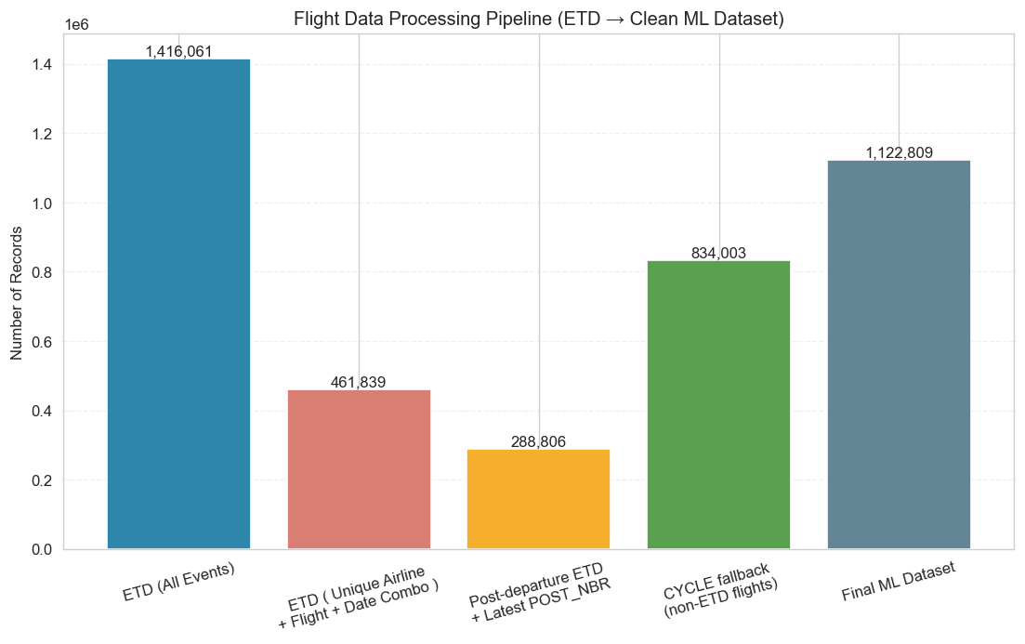
Fig 1: Flight Data Processing Pipeline - ETD to Clean ML Dataset

3.4 Target Variables
Once we filtered the flight records, the next step was to specify target variables for the machine learning models. Since the project addresses both classification and regression tasks, two target variables were created: one to indicate whether a flight was delayed and another to measure the number of delay minutes.
For the classification task, a binary target variable named is_delayed was created to identify whether a flight arrived late. This variable was derived from the arrival delay measure available in the operational records. Flights with arrival delay greater than zero minutes were labeled as delayed, while flights with zero or negative delay were labeled as on time. This transformation converts the delay prediction problem into a binary classification task where the model predicts either Delayed (1) or On-Time (0).

Class | Definition | Record Count | Percentage
0 — On Time / Early | Arrival variance < 5 minutes | 783,272 | 69.7%
1 — Delayed | Arrival variance ≥ 5 minutes | 339,537 | 30.3%
Table5: Classification Target Distribution of Flight Records
The regression target captures the actual delay duration in minutes. For flights that arrived on time or early, the delay value was set to zero. For delayed flights, the arrival variance was used directly. Because the distribution of delay minutes was heavily right‑skewed, a log transformation (log1p) was later applied to normalize the values and improve model performance.
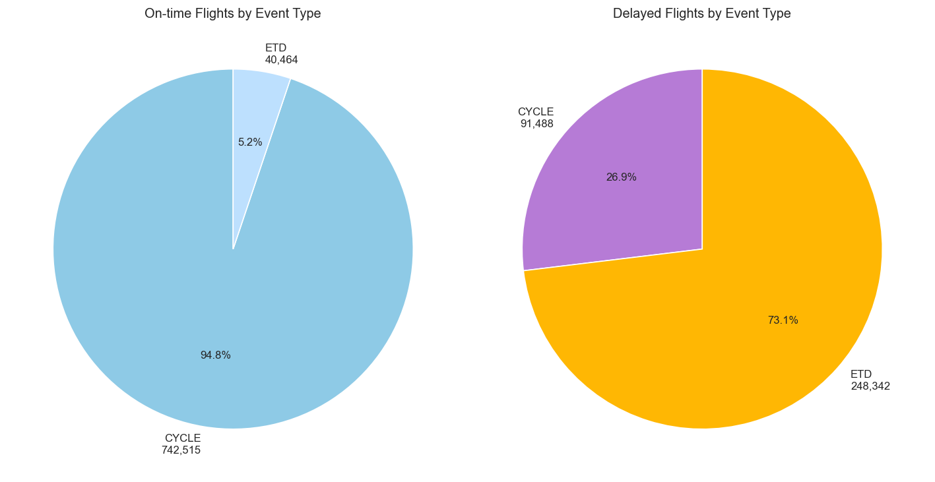
Fig2: On-Time vs Delayed Flights by Event Type
The target variables were generated after the completion of the ETD and CYCLE filtering stages to ensure that each flight had one consistent delay label. By defining both is_delayed and delay_minutes, the dataset was prepared for dual predictive tasks: delay classification and delay duration estimation. This dual-target approach improves the usefulness of the system by enabling both operational delay detection and severity forecasting.
The distribution of the classification target showed that approximately 30.3% of flights were delayed, while 69.7% were on time. This distribution indicates a moderate class imbalance, which was considered during the model evaluation stage. Understanding the target distribution is essential, as it guides the choice of evaluation metrics and shapes how classification performance is interpreted.

3.5 Cleaning & Transforming Date and Time Columns
The raw flight operational dataset consists of several time-stamp variables corresponding to different operational phases of the flight and different events occurring during it. These timestamps were recorded in mixed formats and a complete pre-processing phase was essential for the consistency and the correct extraction of the temporal features.
The initial task was to process all relevant timestamp columns to be represented in a common datetime format using the datetime processing libraries of the Python programming language. The variables of scheduled departure time, scheduled arrival time, actual departure time, actual arrival time and estimated time update were converted into machine-readable datetime objects. To maintain temporal integrity, invalid or incomplete timestamp entries were detected and deleted.
Cleaned datetime columns were then used to extract the following temporal features:
- Departure hour
- Day of week
- Month
- Year
- Weekend indicator
- Holiday season indicator
- Peak hour flag
The features enable the models to incorporate standardized operational patterns that occur during certain times, weekdays and seasons, and that are correlated with fluctuations in traffic.
Selected variables that exhibit cyclical temporal properties (e.g., departure hour, month) were circularly encoded by transforming them into sine and cosine functions. This method eliminates artificial discontinuities which can result from using cyclical variables as numeric variables. For instance, hour 23 and 0 are temporally neighboring hours, but numerically quite far away in the standard encoding.
In addition, scheduled flight duration was computed by calculating the time difference between scheduled departure and scheduled arrival timestamps. This is an operational complexity indicator that is intended to represent route-level aspects of flight that could affect delay probability.
These transformations capture the meaningful signals that are predictive of the data and preserve the temporal consistency necessary for correct machine learning modeling.

3.6 Weather Data — DFW Departure Airport (2021–2025)
One of the most significant external factors that impact airline operational performance is weather. Historical weather data from January 2021 to July 2025 was combined with the flight data to represent the environmental conditions that affect the departures from Dallas/Fort Worth International Airport (DFW).
The data was pulled via the Open-Meteo API with the geographic coordinates of DFW airport. The weather data set contains hourly historical data that are organized according to the scheduled departure time of flights.
The following weather variables were collected:
- Temperature (2m)
- Relative Humidity (2m)
- Dew Point
- Surface Pressure
- Wind Speed (10m)
- Wind Gusts
- Precipitation
- Rainfall
- Cloud Cover
Weather records were collected and then the times were synced with each flight by the scheduled departure time. The closest hourly weather observation to DFW at the time of the flight was added to the operational data for each flight record.
Further binary weather indicators have been created to better represent adverse weather conditions and make models more interpretable
- high_wind_flag: 1 if wind speed exceeded operational threshold
- heavy_precipitation_flag: 1 if precipitation exceeded threshold
- fog_risk_flag: 1 under high humidity and low temperature spread conditions
These weather variables are engineered to assist the model to detect operational disruption scenarios due to poor weather conditions.
Weather data can be integrated into the final predictive models, which can share knowledge from operational signals and weather conditions and thus enhance delay classification and delay duration estimation.

3.6.1 Weather Distribution plots
To better understand the environmental conditions present in the dataset, the continuous weather variables were analyzed using distribution plots. These variables included temperature, relative humidity, wind speed, wind gust, precipitation, and surface pressure. Examining these distributions helps identify the typical weather conditions at departure time and detect extreme weather values that may affect flight performance.
The analysis showed that most flights operated under normal weather conditions, while some variables, particularly precipitation and wind gusts, displayed occasional extreme values. These conditions may correspond to disruptive weather events that increase the likelihood of delays.
The Figure 3 distribution patterns suggest that while most weather conditions are stable, severe weather events are present in a subset of flights and may play an important role in delay prediction.

Weather Statistics:
Feature | Mean | Std | Min | 50%
dfw_temperature_2m | 21.2 | 9.9 | -17.5 | 22.4
dfw_pressure_msl | 1016.1 | 6.8 | 992.8 | 1015.2
dfw_surface_pressure | 994.9 | 6.2 | 972.2 | 994.4
dfw_dewpoint_2m | 12.076 | 9.084 | -27.0 | 14.5
dfw_apparent_temperature | 20.760 | 12.219 | -22.7 | 22.4
dfw_relativehumidity_2m | 59.882 | 20.081 | 8.0 | 60.0
dfw_rain | 0.166 | 0.961 | 0.0 | 0.0
dfw_winddirection_10m | 169.874 | 90.475 | 0.0 | 170.0
Table6: Weather Statistics
Weather parameters were very variable across temperature, pressure, humidity and wind across DFW. The average air temperature was 21.2°C over a range of –17.5°C to 22.4°C at the median temperature. The overall mean of atmospheric pressure (msl and sfc) was unchanged, with means of 1016 hPa and 995 hPa, respectively. The moisture related variables showed wide spread like dew point and relative humidity and were seen to represent different humidity environments. Low rainfall was the general trend with a median of 0.0 mm and high wind direction variability was observed, which was attributed to varying operational weather patterns.

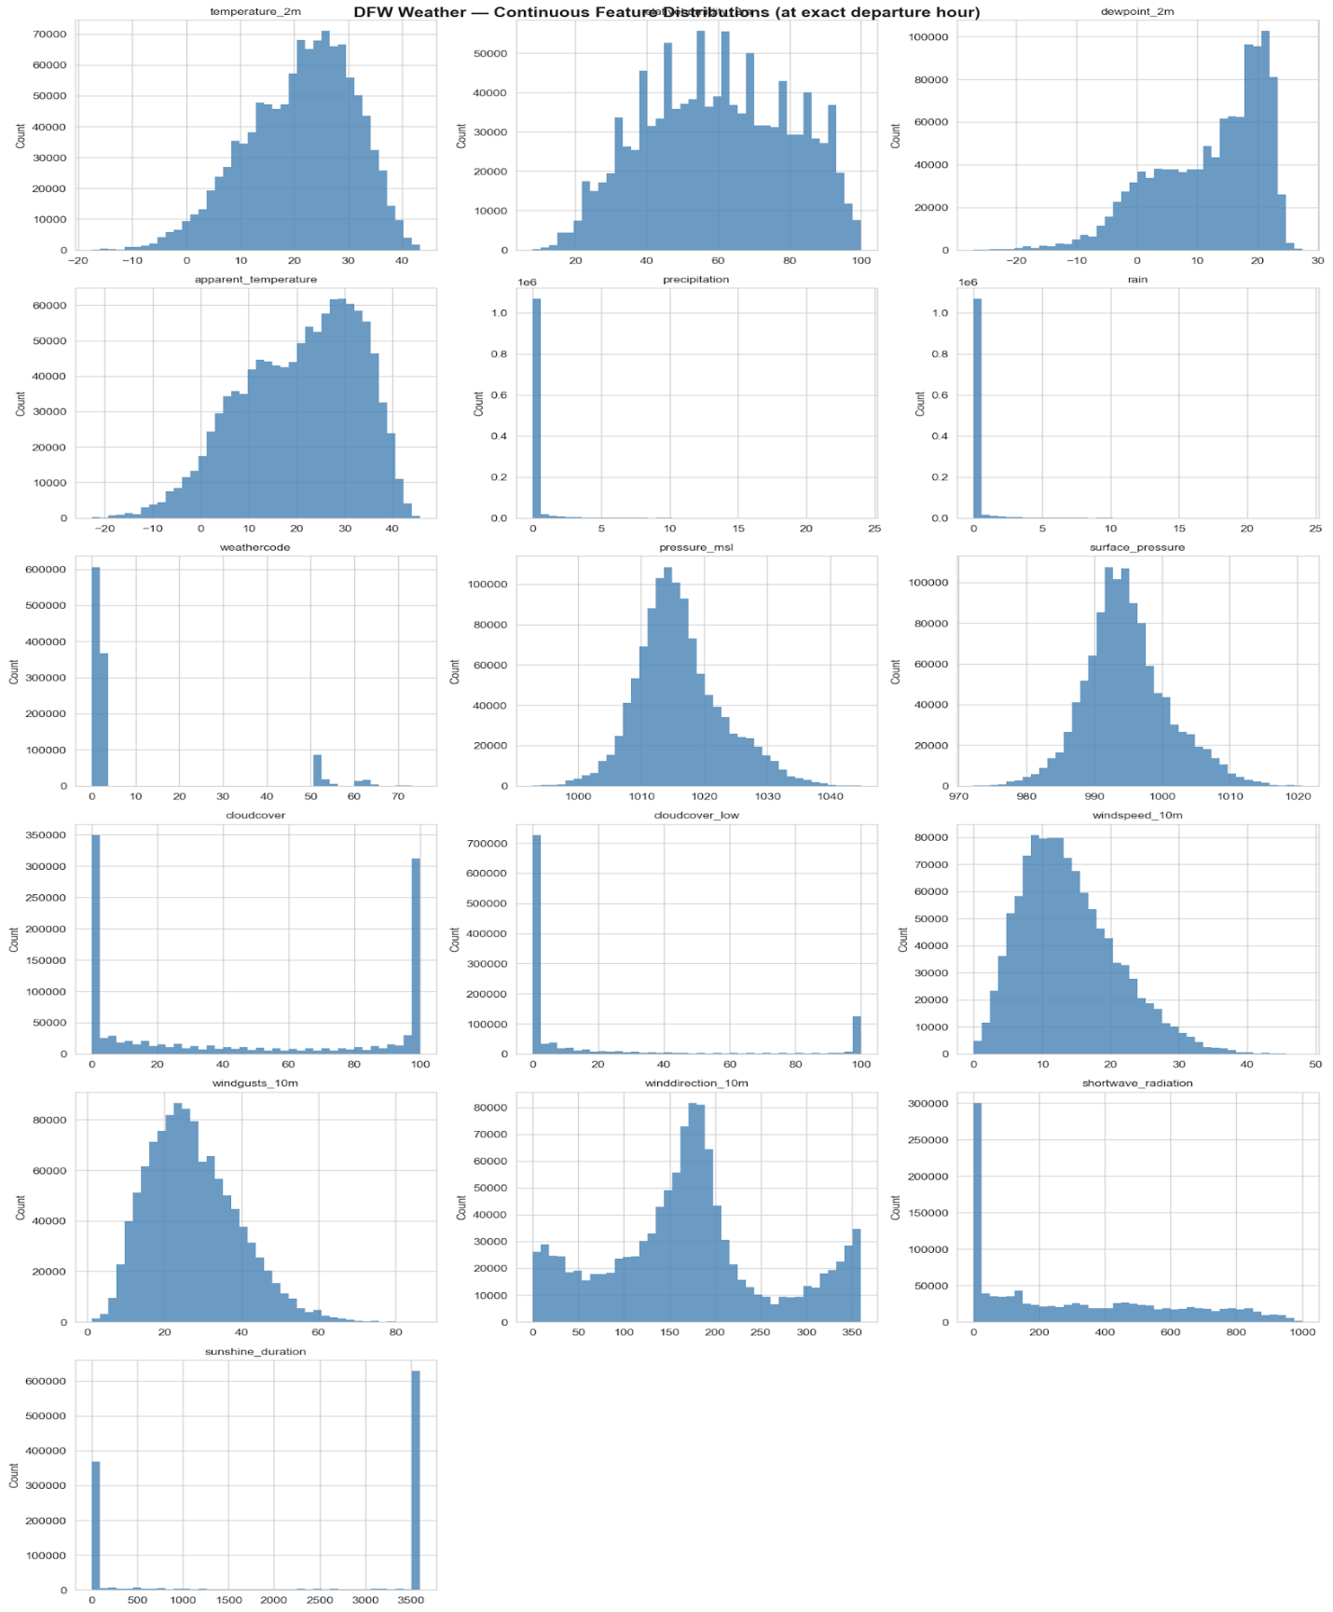
Fig 3: Weather — Continuous Feature Distributions at Departure Hour

Feature | Type | Count | Mean | Min | Max | Description
dfw_temperature_2m | Continuous | 1,122,809 | 21.20 | -17.5 | 43.3 | Air temperature at 2m (°C)
dfw_relativehumidity_2m | Continuous | 1,122,809 | 59.88 | 8.0 | 100.0 | Relative  humidity (%)
dfw_dewpoint_2m | Continuous | 1,122,809 | 12.08 | -27.0 | 27.4 | Dew point temperature  (°C)
dfw_apparent_temperature | Continuous | 1,122,809 | 20.76 | -22.7 | 45.7 | Feels-like  temperature (°C)
dfw_precipitation | Continuous | 1,122,809 | 0.17 | 0.0 | 24.0 | Total precipitation  (mm)
dfw_rain | Continuous | 1,122,809 | 0.17 | 0.0 | 24.0 | Rainfall  component (mm)
dfw_weathercode | Ordinal | 1,122,809 | 8.26 | 0.0 | 75.0 | Weather condition code
dfw_pressure_msl | Continuous | 1,122,809 | 1016.11 | 992.8 | 1044.9 | Mean sea level pressure (hPa)

dfw_surface_pressure | Continuous | 1,122,809 | 994.88 | 972.2 | 1020.7 | Surface pressure (hPa)
dfw_cloudcover | Continuous | 1,122,809 | 45.99 | 0.0 | 100.0 | Total cloud cover (%)
dfw_cloudcover_low | Continuous | 1,122,809 | 18.08 | 0.0 | 100.0 | Low cloud cover (%)
dfw_windspeed_10m | Continuous | 1,122,809 | 13.92 | 0.0 | 48.0 | Wind speed  (km/h)
dfw_windgusts_10m | Continuous | 1,122,809 | 27.37 | 1.1 | 86.4 | Wind gusts (km/h)
dfw_winddirection_10m | Continuous | 1,122,809 | 169.87 | 0.0 | 360.0 | Wind direction (degrees)
dfw_shortwave_radiation | Continuous | 1,122,809 | 306.61 | 0.0 | 1000.0 | Solar radiation (W/m²)
dfw_is_day | Binary | 1,122,809 | 0.78 | 0 | 1 | Daytime  indicator
dfw_sunshine_duration | Continuous | 1,122,809 | 2198.40 | 0.0 | 3600.0 | Sunshine duration (sec)
dfw_wx_severity | Ordinal | 1,122,809 | 0.50 | 0 | 3 | Weather severity index
dfw_is_precip | Binary | 1,122,809 | 0.13 | 0 | 1 | Precipitation  occurrence
dfw_is_thunder | Binary | 1,122,809 | 0.00 | 0 | 0 | Thunderstorm indicator
dfw_high_wind | Binary | 1,122,809 | 0.15 | 0 | 1 | Wind ≥ 40 km/h
dfw_severe_wind | Binary | 1,122,809 | 0.01 | 0 | 1 | Wind ≥ 60  km/h
dfw_heat_stress | Binary | 1,122,809 | 0.00 | 0 | 1 | High temp + humidity
dfw_fog_risk | Binary | 1,122,809 | 0.09 | 0 | 1 | Fog/low visibility risk
dfw_heavy_precip | Binary | 1,122,809 | 0.01 | 0 | 1 | Heavy rainfall indicator

Table7: DFW Weather — Binary/Flag Feature Distributions

3.6.2 Weather Correlation with Delay Targets
To examine the relationship between weather conditions and flight delays, correlation analysis was performed between the weather variables and the target variables is_delayed and delay_minutes. This analysis helps identify which weather conditions are most strongly associated with flight delays.
The results indicated that weather variables such as wind speed, wind gust, and precipitation showed positive relationships with the delay targets, suggesting that adverse weather conditions increase both the likelihood and duration of delays. Similarly, binary weather indicators such as storm and heavy rain flags showed meaningful associations with delayed flights.
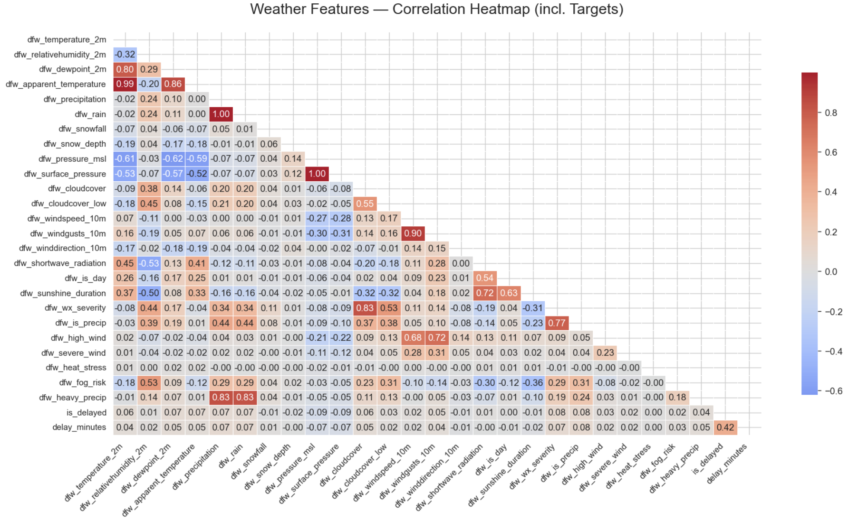Fig4: Weather Features – Correlation Heatmap

These findings confirm that weather-related factors are important predictors and support their inclusion in the machine learning models.

3.7 Data Cleaning
Data was carefully cleaned and standardized to create consistency and reliability, especially before the construction of predictive models. Firstly, duplicate records in the data were removed by creating a composite flight identifier which was made up of airline code, flight number and scheduled departure date and then cleaning the data. The data was systematically handled by missing ETD update data was filled in with CYCLE data, and by missing data of variance values was imputed to zero, which means on-time arrivals. Records were removed from the database if they had invalid values, according to the following rules.Records with invalid values were eliminated to maintain a valid data set as described below.The following rules filtered out records with invalid data: scheduled duration is less than 0; or inconsistent timestamps.
The rest of the cleaning involved cancelling and diverting records to keep only operationally valid records. Other variables were also constrained within reasonable and realistic values, for example minutes to scheduled departure, to ensure the variables have realistic values that do not impact the model. Derived indicators like fleet swap flags were added to reflect the changes in the assignment of the aircraft and could affect the operational performance.
Boxplots were used to plot continuous variables: delay minutes, ETD departure delay, and scheduled flight time to handle outlier data: The visualisations showed that there were a lot of delay minutes that were concentrated towards the right (very long delay times), with a few flights having very long delays. A Winsorization procedure was used to further stabilize the effect of extreme values by clipping numerical variables at the 1st and 99th percentile values, thus removing the influence of extreme observations without changing the distribution of the data. A log transformation (log1p) was also performed on the delay duration variable, to reduce skewness and the instability of the regression models. Incorporated were binary indicators, representing severe weather conditions, for the weather variables, with the aim of effectively capturing all extreme weather conditions but without distorting numerical distributions, as described in the weather integration section.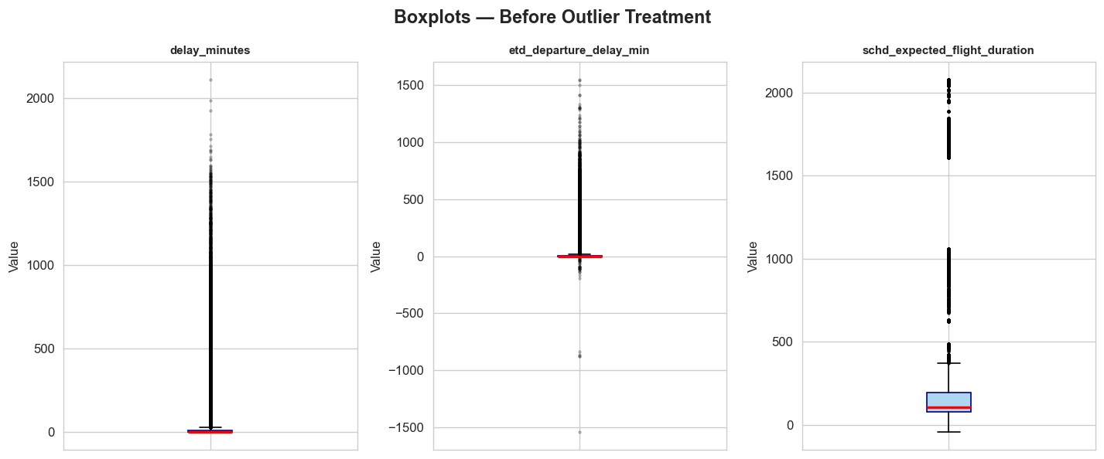
Fig 5 : Boxplots — Before Outlier Treatment
Figure 5 shows the raw distributions of delay_minutes, etd_departure_delay_min, and schd_expected_flight_duration. Each variable exhibits a large number of extreme outliers, with delay minutes extending beyond 2,000 minutes and departure delays ranging between –1,500 and +1,500 minutes. These plots illustrate the variability and irregularities present in the unprocessed dataset. 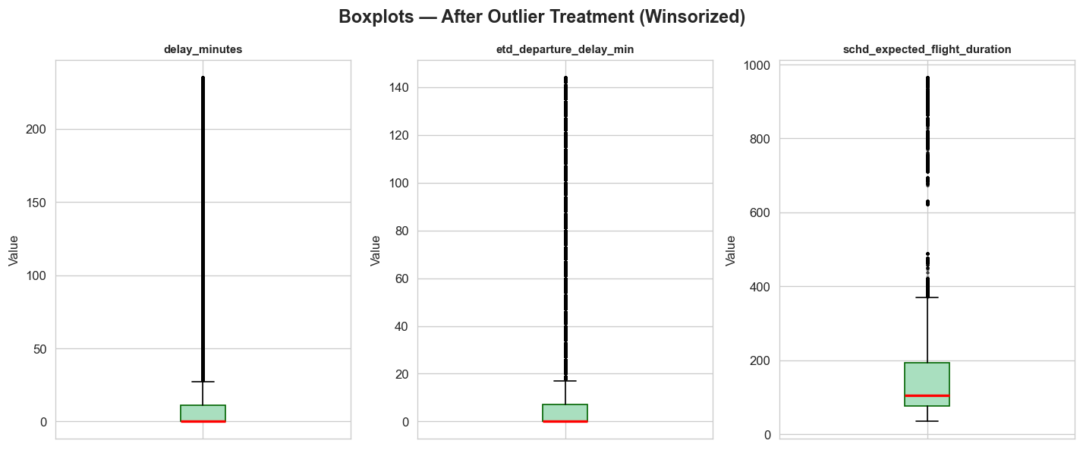
Fig6 : Boxplots — After Outlier Treatment
Figure 6 After applying winsorization, presents same variables. Visually, the distributions of delay minutes are more compact; departure delays are kept within a narrower range, and flight duration are kept realistic, with delays only up to upper percentile values. This can help to minimise the impact of extreme values on the results, but will not remove the spread between the data.
The handling of categorical columns was also very important. Hub airport were indicated by a binary flag, and one-hot encoding was implemented for airline codes, departure airport and arrival airport to ensure that no ordinal bias exists. Other temporal features, like day of week and month, were also encoded and subsequently transformed into cyclical features to maintain the circular nature of these features.
Finally, a few transformations were used to improve the feature representation. Sine and cosine functions were used to encode the departure hour and month to capture cyclical patterns. Where necessary continuous features were transformed and scaled to be consistent to each variable to avoid any dominance of the model because of scale differences. The operational features like ETD update count and TTL_POST_QTY were retained as numeric predictors to keep on real-time operational signals. These pre-processing steps ensured data uniformity, representativeness, and optimization for machine learning.
3.8 Feature Engineering
Feature selection is an important stage in the machine learning pipeline because it eliminates irrelevant and redundant features, reduces data noise, enhances computation efficiency and prevents data leakage. The models can be kept to only the most informative predictors, allowing the models to focus on those variables that give meaningful insight into flight delays.

Feature | Type | Description
MINS_TO_SCHD_DEP_QTY | ETD Signal | Minutes from ETD message to scheduled departure (negative = in-air)
etd_departure_delay_min | ETD Signal | ETD-to-scheduled-departure offset in minutes
etd_volatility_min | ETD Signal | Variance across ETD message updates for same flight
peak_x_etd_delay | Interaction | Peak-hour flag × ETD delay product
flight_nbr_hist_delay_rate | Historical | Expanding mean delay rate per flight number (no leakage)
dep_month_sin / cos | Temporal | Cyclical encoding of departure month
dfw_weathercode | Weather | WMO weather condition code at departure hour
Feature | Type | Description
MINS_TO_SCHD_DEP_QTY | ETD Signal | Minutes from ETD message to scheduled departure (negative = in-air)
etd_departure_delay_min | ETD Signal | ETD-to-scheduled-departure offset in minutes
etd_volatility_min | ETD Signal | Variance across ETD message updates for same flight
peak_x_etd_delay | Interaction | Peak-hour flag × ETD delay product
flight_nbr_hist_delay_rate | Historical | Expanding mean delay rate per flight number (no leakage)
dep_month_sin / cos | Temporal | Cyclical encoding of departure month
dfw_weathercode | Weather | WMO weather condition code at departure hour
Table8: Featire Engineering Description
The engineered features represent operational, temporal, historical and weather-related signals that are relevant to the delay prediction. ETD-based variables (MINS_TO_SCHD_DEP_QTY, etd_departure_delay_min, etd_volatility_min) are measures of the real-time departure update and its stability. The interaction term peak_x_etd_delay is the interaction between peak hour and ETD related delays. Historical behavior will be represented by the flight_nbr_hist_delay_rate, which is a summary of long term delay tendencies for each flight number. Dep_month_sin/cos is used to model temporal seasonality and dfw_weathercode uses a categorical model for weather conditions at the time of departure.

3.8.1 Removal of Identifier Columns
The first step in feature selection was to drop identifier columns present in the flight records, but which do not provide any predictive power. These include flight identifiers, tracking numbers and even record-level keys. Although these attributes are valuable for data management, they are not significant for delay prediction purposes. If these identifiers are added to the data set, they will not help the model and will only add to the complexity of the data set. So these columns were dropped to include only the operational and environmental factors relevant to the model.

3.8.2 Data Preparation and Variance Filtering

All non-numeric attributes (object and datetime) were removed from the modeling dataset to be able to use numbers for analysis. Boolean variables are stored as integer, for consistency of features. Then a variance threshold was applied with a threshold of 0.01 to remove a feature that has a very low variance, which is considered as near-constant feature. Minimal variance features are of little or no predictive value and could cause noise in the model. The data set was further pruned to only include meaningful predictors by removing such variables.

3.8.3 Prevention of Data Leakage

Information added to the variables after the operation was not included in the data set to ensure that only information prior to or at operation was used in the predictive models. These were not included as they would be target leakage features, but rather features that directly reflect the delay outcome, such as arrival based features and the post flight measure. Moreover, a correlation-based leakage checking was performed to get information about the relationship between the predictor variables and the target variable (delay_minutes). Potential variables of leakage were identified by using very high correlation (absolute correlation ≥ 0.84) between a feature and the target and removed. This also ensured that no information arising from the model, or information that cannot be obtained from the model, but can only be looked into the future, would affect the model.

3.8.4: Multicollinearity Check
Multicollinearity occurs when two or more of the predictor variables are highly correlated causing the model coefficients to be unstable, the model to be less interpretable, and possibly leading to a loss of model performance. In order to overcome this, a correlation matrix was used to evaluate the pairwise correlations among numerical features. Inter-correlation (r>0.80) was considered as features that were redundant. To reduce the amount of overlap across the feature space, an overlapping variable from each set of high correlation was removed in these instances. This process guarantees that the feature set added to the final model is informative, without being redundant, leading to better model interpretability and stability.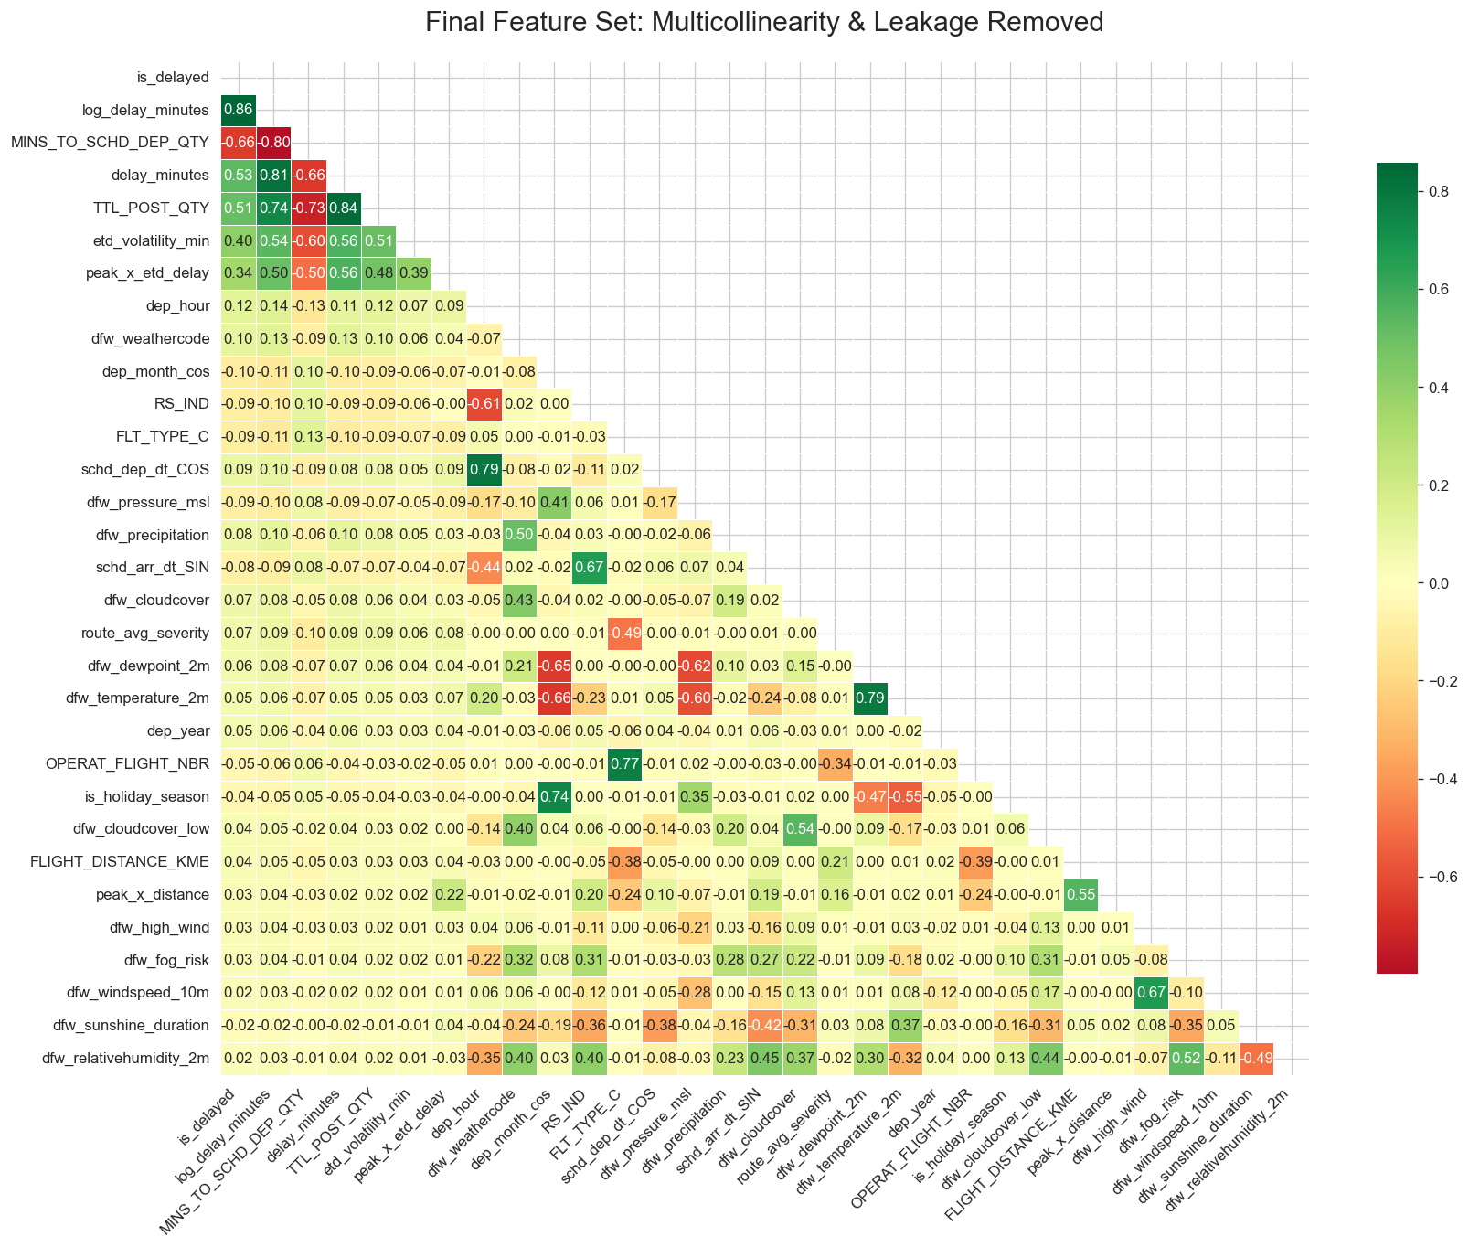
Fig7: Final Feature Set: Multicollinearity & Leakage Removed
Figure 7 illustrates the pairwise correlations among the selected features after removing leakage variables and redundant predictors. The visualization confirms that the final feature set maintains moderate correlations without excessive overlap, supporting a balanced and robust modeling pipeline

CHAPTER 4: EXPLORATORY DATA ANALYSIS (EDA)
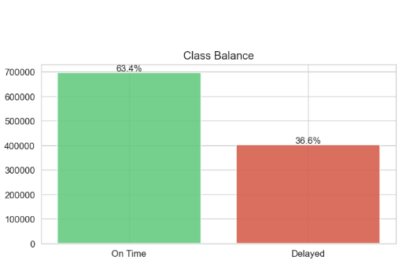
Fig8: Class Balance (On-Time vs Delayed)
The Class Balance chart indicates the overall distribution of on-time and delayed flights in the data: there are approximately 700,000 on-time and delayed flights, respectively (about 63.4 and 36.6, respectively). Such a moderate imbalance shows that although the vast majority of flights arrive on schedule, a significant minority is late, so model evaluation should focus on recalling the delayed class and consider class-weighting or threshold tuning.
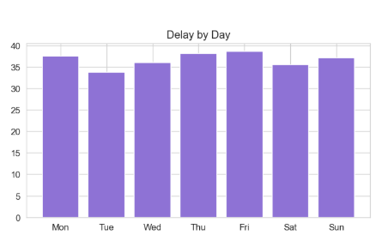
Fig9: Delay Frequency by Day of Week
The Delay by Day chart shows the frequency of delays by each of the seven weekdays and illustrates that delay rates significantly differ across the seven weekdays, but that the difference is relatively small. The pattern indicates that systemic factors (weather, airport operations, traffic volume) cause delays more than a problematic single weekday, thus day-of-week needs to become a feature with operational signals used to create targeted interventions.
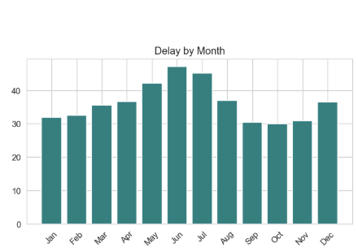
Fig10: Delay Frequency by Month
The Delay by Month chart shows the clear seasonality: the delay rates are lowest in the off peak months and increase during the summer and reach a peak around the months of June and July. This seasonal growth is with higher traffic and weather-related disturbances (e.g., convective storms) and justifies the use of cyclical month encodings or seasonal indicators in the model and planning to have additional capacity during summer months.
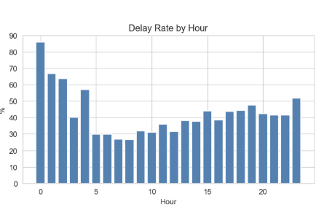
Fig11: Delay Rate by Hour of Day
The Delay Rate by Hour chart indicates that there is strong time-of-day dependence: very high variation of delay rates during the night (an extreme spike at the end hour numbering 0), the lowest delay rates in the early morning recovery period (a sharp spike at the beginning hour numbering 0), and a gradual increase in the evening. These hourly patterns suggest that recovery strategies, resource allocation needs to be hour-conscious, and that time features of cycles as well as tests of small-sample hours (which can give extreme percentages) are important in constructing and interpreting models.
The exploratory analysis provides several important insights:
- Flight delays are moderately imbalanced but predictable
- Delay duration is highly skewed and requires transformation
- Weather variables significantly influence delay behavior
- Temporal patterns impact operational efficiency
- Feature selection is essential to avoid redundancy and leakage
These findings form the foundation for the modeling phase, guiding both feature selection and algorithm choice.

CHAPTER 5: MODELING

5.1 Temporal Train/Test/Validation Split
A time-based splitting technique was employed to partition the dataset to ensure that a realistic assessment of model performance could be obtained and to avoid data leakage. The data were not randomly divided into training, testing, and validation data sets but rather were ordered chronologically and divided into training, testing, and validation sets according to their order.
Around 70% of the data was assigned to the training set for training the machine learning models. The last 20% of data was collected and assigned to the test set for intermediate evaluation and comparison of the model. The remaining 10% was set aside as a validation set for the final model performance on unseen data.
Some of the chronological splitting strategies ensure that the model is always trained on data in the past and tested on observations in the future, much like how it would be used in the real world. In time-dependent problems such as flight delay prediction, for example, future information cannot be used to train the model.
After splitting, the input features (X) and target variables (y) were divided into separate sets for each data set. To prevent leakage all the target related columns such as delay indicator and delay duration variables were excluded from the feature set. The missing values in the feature space were filled with zero for consistency over the datasets.

Split | Row Count | Share | Time Period (Approximate)
Training | 767,326 | 70% | Jan 2021 – Sep 2024
Test | 219,236 | 20% | Sep 2024 – May 2025
Validation (Held-Out) | 109,619 | 10% | May 2025 – Jul 2025
Table9: Dataset Split Summary for Model Development

5.2 Classification Model
The task of classification is to determine the delay or on-time flight based on the operational and environmental characteristics. To do this, several machine learning models were deployed and tested with each other to determine the most effective model. The models that will be used are both linear and ensemble-based algorithms to model various kinds of relationships in the data.

5.2.1 Classification models used
Logistic Regression was used as the baseline model because it can give an interpretable linear decision boundary and is a handy benchmark to assess more complicated algorithms.
Random Forest was used as an ensemble model that combines multiple decision trees to improve predictive performance and capture non-linear relationships between the input features and flight delays.
XGBoost was chosen since it is a strong gradient boosting algorithm that can learn the multifaceted interaction between features effectively and can handle class imbalance.
LightGBMwas also an optimized gradient boosting algorithm that is efficient to train large datasets and high predictive performance.
Table 10 below presents the model parameters
Model | Parameters
XGBoost | n_estimators = 300, max_depth = 6, learning_rate = 0.05, subsample = 0.8, colsample_bytree = 0.8, scale_pos_weight = (class imbalance ratio), eval_metric = "logloss", tree_method = "hist", random_state = 42
LightGBM | n_estimators = 300, max_depth = 6, learning_rate = 0.05, subsample = 0.8, colsample_bytree = 0.8, class_weight = "balanced", random_state = 42
Random Forest | n_estimators = 100, max_depth = 12, class_weight = "balanced", max_samples = 0.1, random_state = 42
Logistic Regression | max_iter = 1000, class_weight = "balanced", random_state = 42
Table10: Classification models and their parameters

5.2.2 Classification Results –Testset
Four classification models were trained to predict is_delayed (binary: delayed vs. on time). On the held-out 20% test set, all four models were assessed using AUC-ROC, Accuracy, Recall for the delayed class, and F1-Score for the delayed class. Table 11 below displays the results.

Model | Accuracy | Recall (Delayed) | F1 Score (Delayed) | AUC-ROC
XGBoost | 0.8556 | 0.6958 | 0.7851 | 0.8745
LightGBM | 0.8554 | 0.6959 | 0.7850 | 0.8736
Random Forest | 0.8568 | 0.6826 | 0.7833 | 0.8693
Logistic Regression | 0.8568 | 0.6831 | 0.7835 | 0.8566
Table11: Classification Model Comparison – Test Set Results

The evaluation metrics provide different perspectives on model performance:
- Accuracy measures overall correctness of predictions
- Recall (Delayed) indicates the model’s ability to correctly identify delayed flights. A recall of 0.6958 means the model detects approximately 70% of all delayed flights
- Precision reflects how reliable delay predictions are, reducing false alarms
- F1-score balances precision and recall
- AUC-ROC evaluates the model’s ability to distinguish between delayed and on-time flights across all thresholds
In flight delay prediction, recall is particularly important because missing a delayed flight can negatively impact operational planning.
The results show that XGBoost achieved the highest AUC-ROC score of 0.8745, indicating the best overall ability to distinguish between delayed and non-delayed flights. LightGBM produced nearly identical performance, while Random Forest and Logistic Regression achieved slightly higher accuracy but lower delayed-flight recall and lower AUC-ROC values.
Although Random Forest and Logistic Regression showed marginally better overall accuracy, XGBoost provided better balanced performance for identifying delayed flights, which is particularly important in flight delay prediction. For this reason, XGBoost was identified as the strongest classification model among the four algorithms tested.

5.2.3 ROC Curve Comparison
To compare the performance of different classifiers, ROC curves were generated using the held-out test set. The curves illustrate the trade-off between True Positive Rate (TPR) and False Positive Rate (FPR).
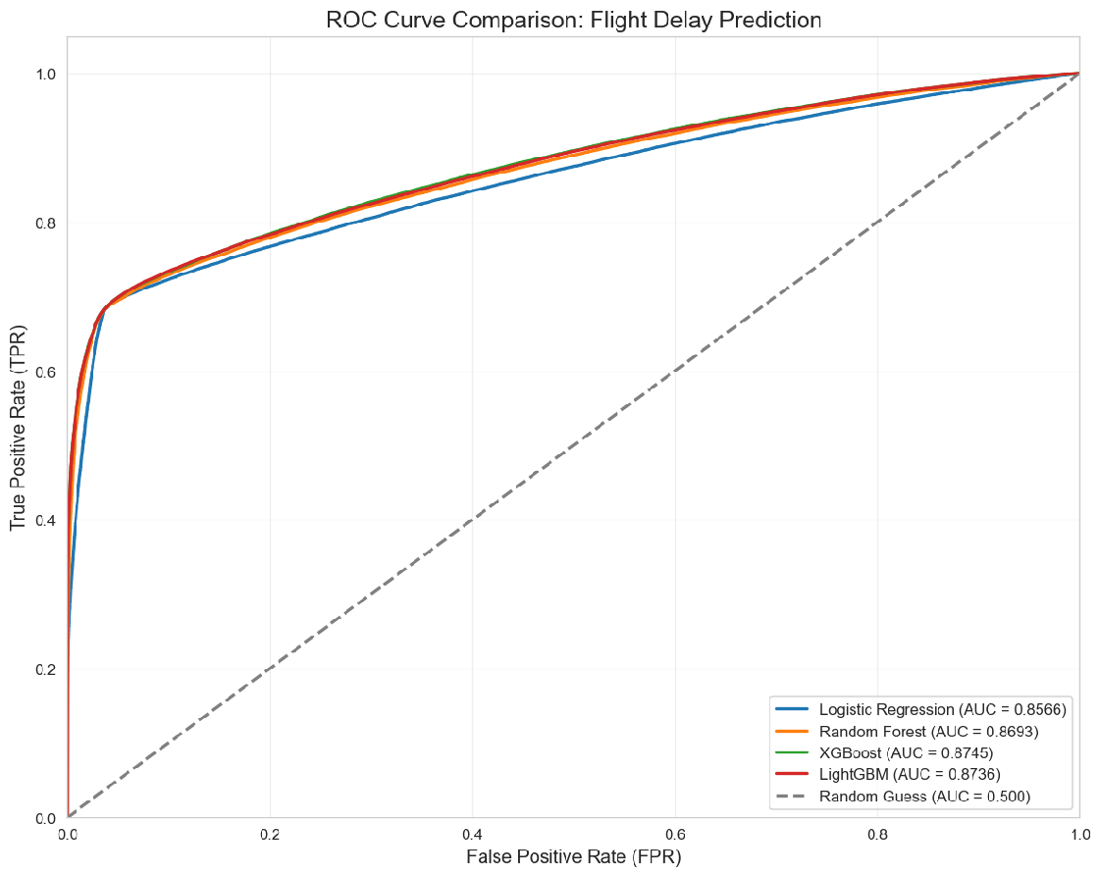Fig12: ROC Curve Comparison – All Classification Models
Figure 12 shows the ROC curves for the Logistic Regression (AUC = 0.8566) model, Random Forest (AUC = 0.8693), XGBoost (AUC = 0.8745), and LightGBM (AUC = 0.8736). The random guess baseline with (AUC = 0.500) is included for reference. The results confirm that ensemble methods, particularly XGBoost and LightGBM, achieved the highest predictive performance.

5.2.4 Calibration Curve
The reliability of the predicted probabilities of the classification model was assessed using a calibration curve.
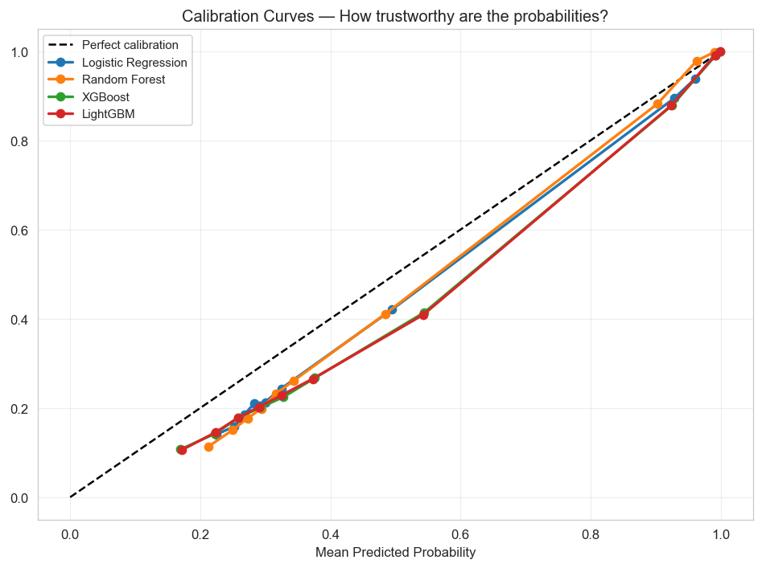
Fig 13: Calibration Curve

The calibration curves of the classification models (Logistic Regression, Random Forest, XGBoost and LightGBM) are shown in Figure 13. To determine the goodness of fit between the observed probabilities and the probabilities predicted by each model, both models are tested using the calibration curve.

The dashed diagonal line is the ideal calibration line—when the predicted probability is equal to the actual probability of the delay occurring. The closer the curve of a model is to this diagonal line, the better the model is calibrated.

The four models have fairly good calibration ability, as the curves for each model are located towards the ideal diagonal over most of the probability range, as seen in the figure. This means that the forecasts are around the right level and are representative of the actual risk of flight delay.

If the models perform well around the diagonal, then in the range of mid-range probabilities (around 0.2 to 0.6), they all perform well, which means that the models are doing well in the most critical regime for the decision making process. However, for higher probabilities (above 0.8), there are some slight deviations from the diagonal which could reflect underestimation or overestimation of delay probabilities. However, the deviations are rather small and have negligible impact on reliability.

5.2.5 CLASSIFICATION VALIDATION RESULTS (HELD OUT 10%)
Following a comparison of the four classification algorithms on the testing dataset, the XGBoost was found to be the best-performing model, in terms of the highest AUC-ROC score. In order to verify generalization to unseen data, the model was also tested on the held-out validation dataset, which was the last 10 percent of the records.
Validation dataset was not trained or compared to another model, and it is a separate benchmark to test the robustness of the model. The validation data was used to apply the XGBoost classifier whose performance was assessed through Accuracy, Precision, Recall, F1-score and AUC-ROC.
Metric | Value
Validation Accuracy | 0.8365
Validation AUC-ROC | 0.8712
Precision (Delayed) | 0.91
Recall (Delayed) | 0.70
F1-Score (Delayed) | 0.79
Table 12: Classification Model Comparison – Test Set Results
The validation findings indicate that the XGBoost classifier has AUC-ROC score of 0.8712 and accuracy of 83.65 indicating that the algorithm is a strong predictive of the unknown validation data.
This model had a precision of 91% in terms of delayed flights which means that in most cases, the prediction of the model was accurate when it was predicted to be delayed. This sensitivity is useful in the workplace where we would want to reduce the number of false alarms.
The delayed flight recall rate was 70% which indicates that the model was able to identify most of the delayed flights, but not all of the delayed flights were captured. The F1-score of 0.79 represents an equal trade-off between precision and recall.
These validation findings indicate that the XGBoost model was still able to maintain predictive accuracy outside the testing data, which means that the model could generalize well, and thus, it can be used to predict the operational delay.

5.2.6 CLASSIFICATION CONFUSION MATRIX
To assess the classification performance of the chosen XGBoost model, a confusion matrix was considered on the held-out validation dataset. The confusion matrix is used to give a detailed analysis of the correct and incorrect predictions of both delayed and on-time flights. The model overall is well predictive, it made 57835 correct on time flight predictions and 33865 correct delayed flight predictions, according to the confusion matrix.
The false positive cases were 3520 which were the number of true on-time flights that were forecasted as delayed. These are those flights that had been punctual but were wrongly rated as being delayed. The false negative cases were the number of true delayed flights that were predicted to be on-time 14399.
They are late flights which the model could not detect. According to the confusion matrix, the model is especially good at recognizing on-time flights since the number of records that are correctly identified as on-time and the number of false positives is significantly high and low respectively.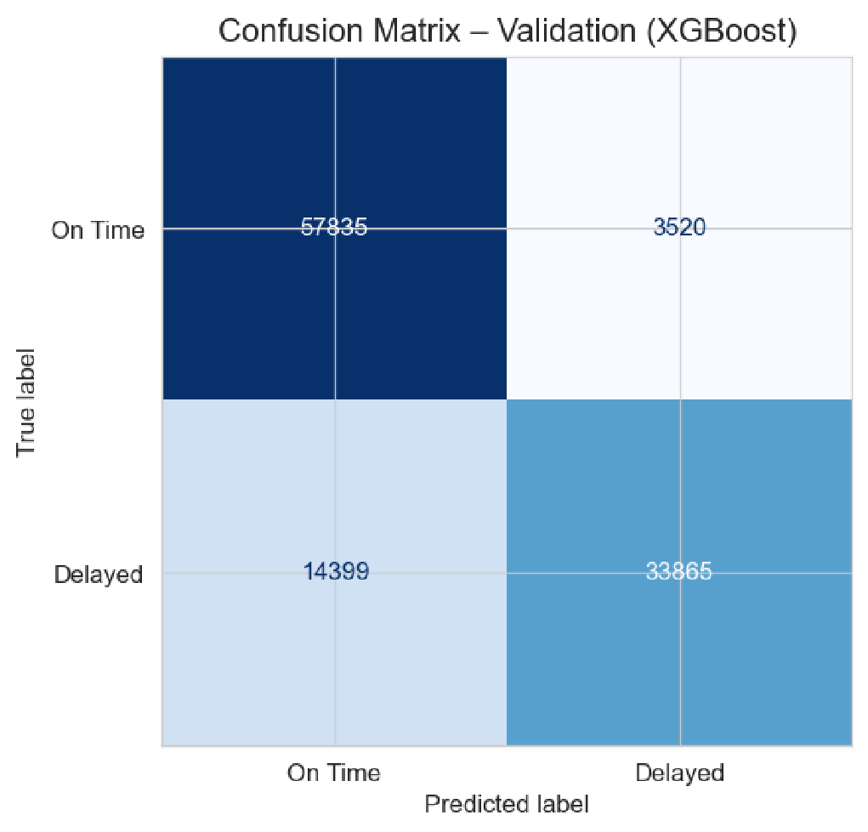
Fig14: Confusion Matrix – XGBoost Classification Validation (Held-Out 10%)

5.3 Regression Model

The regression data set included all flights (on-time and delayed flights), but the length of delay was coded as zero. This made sure that the models got to learn about all the outcomes of the flights that included delayed and non-delayed flights. As in the classification task, the ready data set was split in chronological order into a training, testing and validation subset of 70, 20 and 10 percent. This resulted in 767,326 training records, 219,236 test records and 109,619 validation records. To ensure that the set of predictors was free of target related variables, and that only valid explanatory variables were used for training the models, leakage check was also performed.

Two types of gradient boosting regression models were trained: XGBoost Regressor, LightGBM Regressor. The selection of these models is justified because gradient boosting methods are very effective when operating on structured tabular data, and they can be applied to model non-linear relationships between operational variables, weather variables and delay duration. Both models were set up with 500 estimators, a maximum tree depth of 6, and a learning rate of 0.05, which offers enough complexity to the model, and still allows it to generalize.

5.3.1 REGRESSION RESULTS – TEST SET
The testing data were tested on the models in terms of Mean Absolute Error (MAE), Root Mean Squared Error (RMSE), and R² Score. These metrics were selected to evaluate the accuracy of prediction in various aspects. MAE is the mean absolute discrepancy between the predicted and actual delay minutes, RMSE highlights greater prediction errors and the R 2 Score indicates the extent to which the model accounts for the variation in delay duration.
Model | MAE (Minutes) | RMSE (Minutes) | R² Score
XGBoost Reg | 9.7195 | 25.5799 | 0.7314
LightGBM Reg | 9.7050 | 25.6106 | 0.7295
Table 13: Regression Results – Test Set
The comparison of the results revealed that XGBoost Regressor was better than LightGBM Regressor and it outperforms LightGBM Regressor in all the performance measurements. The XGBoost model had a Mean Absolute Error of 9.7195 minutes which means that the model had an error margin of nine minutes on average with the actual delay duration. It also was able to control larger prediction errors with a better root mean squared error of 25.5799 minutes. Moreover, the model attained an R 2 Score of 0.7314, which implies that the model was able to explain about 73.14 percent of the difference in delay time.

5.3.2 Regression Validation Results
The XGBoost Regressor was tested on the held out 10% validation set to test its generalization performance. The model had a mean absolute error (MAE) of 11.38 minutes, which means that predictions were in general 11 minutes off actual delay time. The root mean squared error (RMSE) was 27.28 minutes which indicates the effects of bigger errors in the distribution. The coefficient of determination (R 2 ) was 0.7232 indicating that out of the log transformed delay minutes, the model explained about 72 percent of the variance. These findings support the idea that XGBoost was able to capture meaningful patterns within the data.
Metric | Value
MAE (Minutes) | 11.38
RMSE (Minutes) | 27.28
R² Score | 0.7232
Table 14: Regression Validation Results

5.3.3 Regression — Error Analysis
To measure further the performance of the regression, the difference between the actual and predicted delay minutes on the validation set was measured as the residuals. The distribution of residuals is shown in Figure 15
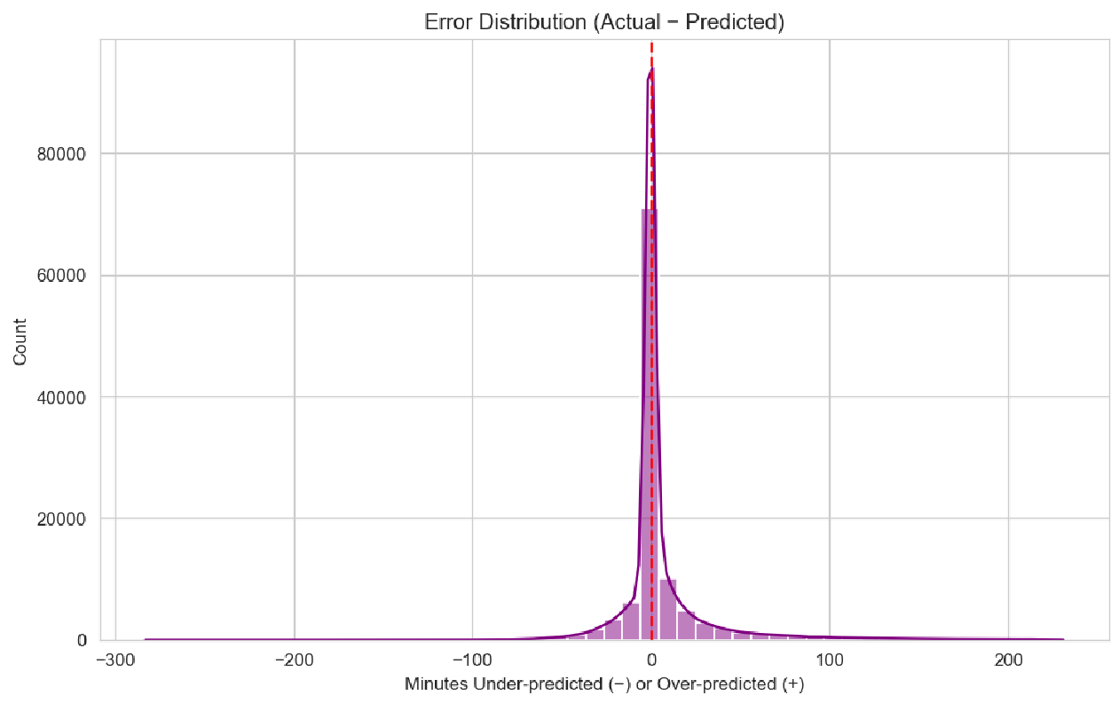
Fig 15: Error Distribution (Actual − Predicted)
The histogram shows that there is a concentration of most of the errors around the zero point with a sharp peak showing that most of the predictions closely coincide with the actual delay times. Distribution is roughly centered with a mean residual of 0.00 minutes, which ascertains that the model does not systematically over predict or under predict delays. The great length of the tails in either direction, however, emphasize the infrequent huge deviations, showing how much variability there is in flight business, and how hard it is to model extreme delayed times.
This analysis of residual values (MAE = 11.38 minutes, RMSE = 27.28 minutes, R 2 = 0.7232) is a visual confirmation that the XGBoost Regressor can effectively represent the majority of delay patterns.

5.3.4 Regression — Actual vs. Predicted
In order to visualize regression performance, the predicted delay minutes versus actual delay minutes of the held-out test set were plotted and zoomed to the 99 th percentile in order to minimize the impact of extreme outliers. Figure 16 shows the scatter of predictions compared to the diagonal perfect prediction line.
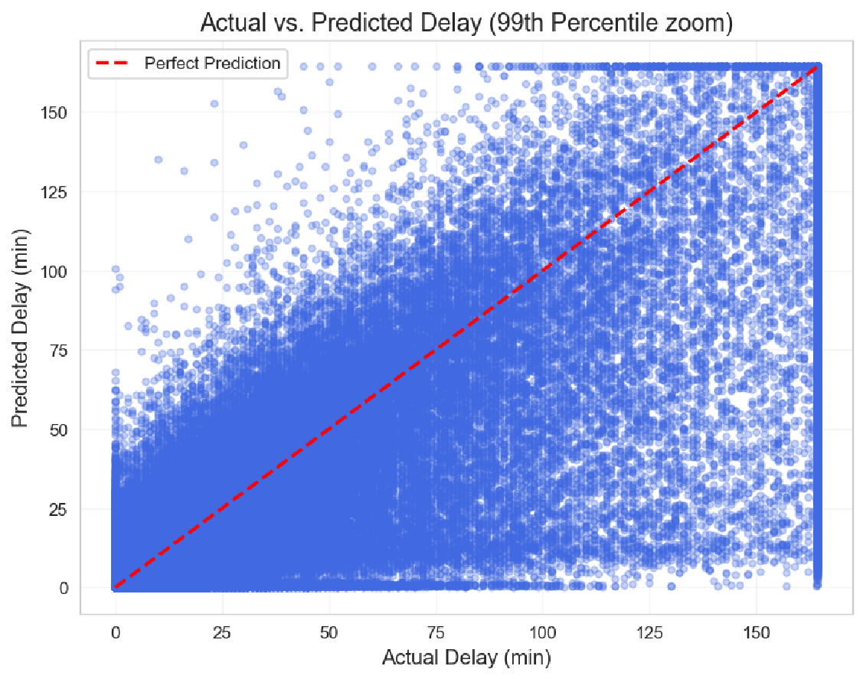
Fig 16: Actual vs. Predicted Delay
Most of the points are closely clustered around the diagonal, which proves that the central tendency of delay durations is well represented by the model. Deviations off the line are an indication of errors in prediction, some under prediction and over prediction are evident, especially when the delay is longer. The visualization highlights the accuracy of the model at the 99th percentile of flight delays that are typical, but also that extreme cases are harder to predict.
This analysis is complementary to the residual distribution and validation metrics, which supports the idea that the XGBoost Regressor can predict the majority of flights with good accuracy.

5.3.5 Regression — Feature Importance
To interpret the regression model, the XGBoost Regressor provided the feature importance scores. Figure 17 indicates the strongest predictors of minutes of flight delay.
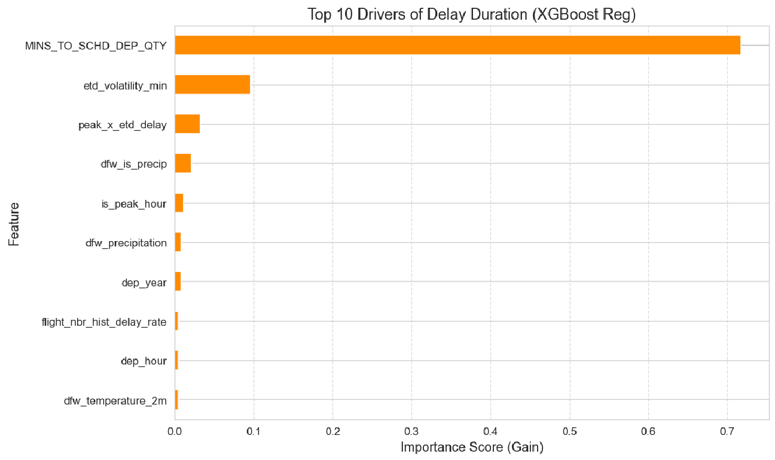
Fig 17: Top 10 Drivers of Delay Duration(LightGBM Reg)
As it can be seen, operational signals like TTL_POST_QTY and etd_volatility_min were some of the strongest drivers indicating the significance of post departure updates and volatility in estimated times. These temporal encodings such as schd_dep_dt_COS were among the highest ranking encodings, since they absorbed cyclical patterns in departure times. The variables of route and distance (FLIGHT_DISTANCE_KME, dep_year) played a significant role and weather variables like dfw_pressure-msl, dfw-dewpoint-2m, dfw-temperature-2m, and dfw-windspeed-10m provided essential background to the operational disruption.
Such ranking ascertains that the model incorporates an equal balance of operational, temporal, route, and weather characteristics to forecast delay periods. The analysis is more useful in terms of interpretability and actionable insights on factors that play the most significant role in flight delays by quantifying the importance of features.

5.4 Hyperparameter Tuning and Final Model Optimization
Hyperparameter tuning was conducted to enhance the performance of the modeling with the help of RandomizedSearchCV that is an efficient way to search a subset of parameter combinations rather than exhaustive grid search.

5.4.1 XGBoost Classifier Tuning
In the classification task, the XGBoost classifier was used with RandomizedSearchCV to find the best combination of parameters with many candidate values. The tuning experiment investigated the changes in the number of trees, maximum tree depth, learning rate, minimum child weight, gamma, subsampling ratio and column sampling ratio. The 3-fold cross-validation was performed on 15 random combinations of parameters, and AUC-ROC was adopted as a scoring metric. This method facilitated effective search of the hyperparameter space as well as lowering the cost of computation than exhaustive grid search.
The tuning process selected a set of the best XGBoost classification parameters as follows: 300 estimators, maximum depth of 4, learning rate of 0.01, minimum child weight of 10, subsample ratio of 0.7 and column sampling ratio of 0.8. These tune parameters enhanced the balance of the model between predictive and generalization.
Parameter | Value
n_estimators | 300
max_depth | 4
learning_rate | 0.01
min_child_weight | 10
gamma | 0
subsample | 0.7
colsample_bytree | 0.8
Table 15: Tuned Hyperparameters of XGBoost
In the case of the regression task, the regression model that was tested with RandomizedSearchCV was the LightGBM Regressor. The tuning procedure considered the number of trees, number of leaves, maximum depth, learning rate, regularization parameters, and minimum number of child samples. The 15 combinations of parameters were tested with the help of 3-fold cross-validation and negative mean absolute error as the evaluation measure. The optimum regression setup identified in this process was 700 estimators, 31 leaves, maximum depth of 6, learning rate of 0.01, minimum child samples of 100, and regularization parameter lambda of 0.1.
Parameter | Value
n_estimators | 700
num_leaves | 31
max_depth | 6
learning_rate | 0.01
reg_alpha | 0
reg_lambda | 0.1
min_child_samples | 100
Table 16: Tuned Hyperparameters of LightGBM
Upon hyperparameter optimization, the optimized XGBoost classifier was retrained on the training data with the classification threshold being optimized to enhance the F1-score. The default probability threshold of 0.50 was not used but a number of threshold values between 0.30 and 0.75 were tested and the one that gave the best F1-score was chosen. The best trade off was identified to be 0.45 giving the best compromise between precision and recall in delayed flight detection.

5.4.2 Model Tuning Comparison – Before vs After Tuning
Classification Model (XGBoost)
Model | Accuracy | Recall (Del.) | F1 (Del.) | AUC-ROC
XGBoost (Tuned) | 0.86 | 0.69 | 0.7844 | 0.8705
XGBoost (Default) | 0.8556 | 0.6958 | 0.7851 | 0.8745

Table17: Classification Model Metrics
Regression Model (XGBoost)
Model | MAE (min) | RMSE (min) | R²
XGBoost (Tuned) | 9.73 | 25.60 | 0.7304
XGBoost (Default) | 9.719 | 25.580 | 0.731
Table18: Regression Model Metrics
From Table 17 and Table 18 hyperparameter tuning results indicate that the default XGBoost model performs slightly better than the tuned version across key evaluation metrics, particularly AUC-ROC and F1-score. Although multiple parameter combinations were explored using RandomizedSearchCV, the tuned model did not provide significant performance improvements. In some cases, performance slightly decreased compared to the default configuration.
Therefore, the default XGBoost model is retained as the final model for both classification and regression tasks, as it provides better overall performance and stability.

5.5 FINAL TUNED MODEL RESULTS
The last tuned XGBoost classifier had a AUC-ROC score of 0.87 on the testing set, and a total accuracy of 86%. In the case of delayed flights, the model was found to be 91 percent precise, 69 percent recall and F1-score of 0.78, which is a good result in terms of detecting delay events and reducing false alarms.

Metric | Value
Accuracy | 0.86
AUC-ROC | 0.87
F1-Score (Delayed) | 0.78
Table 19: Final Tuned Model Results For Classification
In the regression task, the tuned XGBoost Regressor had a Mean Absolute Error of 9.73 minutes, a Root Mean Squared Error of 25.6minutes, and an R2 Score of 0.7585 on the test data. These findings suggest that the final regression model could predict the delay duration with a relatively small error as well as it was able to explain a significant portion of the delay duration variation (approximately 73.04%).
Metric | Value
MAE | 9.73 minutes
RMSE | 25.6 minutes
R² Score | 0.7304
Table 20: Final Tuned Model Results For Regression

SHAP
- Operational Indicators (Highest Impact): SHAP analysis showed that operational features—MINS_TO_SCHD_DEP_QTY, TTL_POST_QTY, and etd_volatility_min—were the strongest contributors to delay prediction. These variables emphasize the importance of pre-departure updates and the instability of estimated departure times in shaping delay risk.
- Temporal Characteristics: Time-based features, including dep_year, dep_hour, and dep_month_cos, also demonstrated substantial influence. Their contributions reflect seasonal, cyclical, and time-of-day patterns that commonly affect flight operations.
- Weather-Related Factors: Environmental variables such as dfw_pressure_msl, dfw_precipitation, dfw_relativehumidity_2m, and dfw_dewpoint_2m played a meaningful role in the model’s predictions. These findings highlight the sensitivity of delay risk to atmospheric and meteorological conditions.
- Route-Level Characteristics: Features like FLIGHT_DISTANCE_KME and route_freq provided additional predictive value by capturing route complexity, traffic density, and variability in congestion across different flight paths.
Feature | Direction | Interpretation
MINS_TO_SCHD_DEP_QTY | ↑ High → ↓ delay | Longer pre-dep window = less rush = less delay
etd_volatility_min | ↑ High → ↑ delay | Volatile ETD = operational instability
flight_nbr_hist_delay_rate | ↑ High → ↑ delay | Historically problematic routes/numbers
peak_x_etd_delay | ↑ High → ↑ delay | Peak-hour + ETD push = worst affected
dfw_pressure_msl | ↓ Low → ↑ delay | Low pressure = storm systems at DFW
Table 21: Feature Interpretation
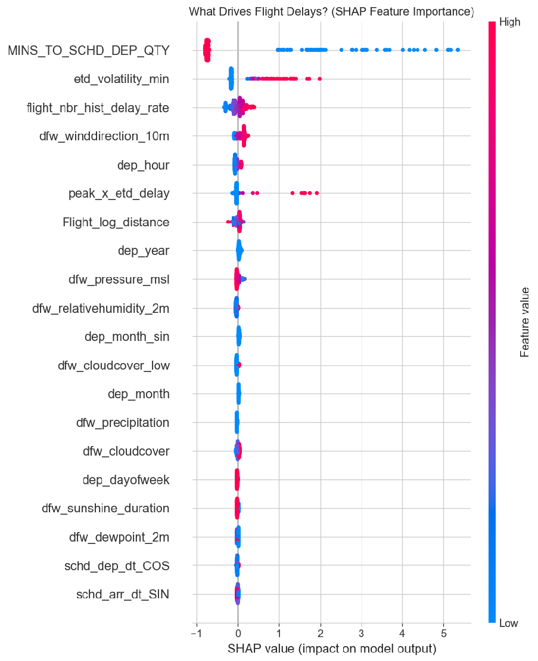
Fig 18: What Drives Flight Delays? (SHAP Analysis)
In the SHAP summary plot:
• Red color represents high feature values
• Blue color represents low feature values
• X-axis:
- Positive values indicate increased probability of delay
- Negative values indicate reduced probability of delay
For example:
- High wind speed (red points) pushes predictions toward delay
- Low wind speed (blue points) pushes predictions toward on-time
This visualization helps explain how individual features contribute to model predictions and improves interpretability.

CHAPTER 6: CONCLUSION
In this study, a two-stage machine learning framework was developed to predict flight arrival delays using large-scale flight operational data combined with historical weather information. The results provide clear answers to the research questions and demonstrate the effectiveness of the proposed approach.
Research Question 1: Can we forecast whether an aircraft will be delayed before takeoff?
Yes. The XGBoost classification
model achieved strong performance, with an AUC-ROC score of approximately 0.87 and an accuracy of around 85% on the test dataset. The model achieved a precision of 0.91 for delayed flights, indicating that when a delay is predicted, it is highly reliable. The recall of approximately 0.70 shows that the model successfully identifies most delayed flights, although some delays remain undetected.
These results demonstrate that the model is effective for early delay detection and can be used in real-time airline monitoring systems to support proactive decision-making.
Research Question 2: Can we forecast the length of a delayed flight?
Yes, to a reasonable degree of accuracy. The XGBoost regression model achieved a Mean Absolute Error (MAE) of approximately 9.7 minutes, a Root Mean Squared Error (RMSE) of approximately 25.6 minutes, and an R² score of approximately 0.73 on the test dataset.
These results indicate that the model can capture the majority of variability in delay duration and provide meaningful estimates of delay severity. While extreme delays remain challenging to predict, the model performs well for typical operational scenarios.

Research Question 3: Do weather variables significantly impact flight delays?
Yes. The analysis confirms that weather variables such as wind speed, wind gusts, and precipitation have a strong influence on both delay occurrence and delay duration. Correlation analysis and feature importance results show that adverse weather conditions increase both the likelihood and severity of delays.
Additionally, derived weather indicators such as high wind and heavy precipitation flags further improved the model’s ability to capture disruption scenarios. These findings highlight the importance of integrating environmental data into delay prediction systems.
Research Question 4: Can the model generalize effectively to unseen future data?
Yes. The use of a temporal train-test-validation split ensured that the model was evaluated on future unseen data, simulating real-world deployment conditions. The validation results show consistent performance compared to the test set, indicating that the model does not suffer from data leakage and generalizes well over time.
This confirms that the proposed approach is suitable for real-world applications where predictions must be made on future flights.
Final Summary
Overall, the two-stage modeling framework combining classification and regression provides a comprehensive and interpretable solution for flight delay prediction. The system not only detects potential delays but also estimates their severity, making it highly valuable for operational planning.
From a business perspective, this system can support:
- Proactive airline decision-making (crew and gate allocation)
- Improved airport resource planning
- Enhanced passenger communication through early delay alerts
These capabilities demonstrate the practical value of the proposed solution in improving efficiency and reliability in airline operations.

6.1 Limitations and Future Work
There are various limitations to this study. Using hourly or sub-hourly weather data or using live weather data bases on flight latitude and longitude would more accurately capture the meteorological conditions at the specific departure or arrival time. Initially, the weather data was obtained at the daily level. Second, a production deployment would necessitate frequent retraining because the models were trained on a fixed
historical snapshot and do not take seasonal or trend-based changes in delay patterns into consideration. Third, there is a significant amount of unexplained variance in the regression model's R-squared of 0.63. Future studies that consider route weather, airplane equipment type, and linking flight network status may be able to enhance delay magnitude forecasts. Lastly, a comprehensive probabilistic forecasting method that produces a distribution over delayed minutes instead of a point estimate could be added to the two-stage framework

REFERENCES
- Guan Gui; Fan Liu; Jinlong Sun; Jie Yang; Ziqi Zhou; Dongxu Zhao (January 2020). Flight delay prediction based on aviation big data and machine learning. IEEE Transactions on Vehicular Technology, 69(1), 140–150. https://doi.org/10.1109/TVT.2019.2954094 .
- Khaksar, H., &Sheikholeslami, A. (December 2017). Airline delay prediction by machine learning algorithms. Scientia Iranica, 26(5), 2689-2702.
https://www.researchgate.net/publication/323161515_Airline_delay_prediction_by_machine_lear
ning_algorithms
- Young Jin Kim; Sun Choi; Simon Briceno; Dimitri Mavris. (December 2016). A deep learning approach to flight delay prediction. In Proceedings of the 35th Digital Avionics Systems Conference (DASC) (pp. 1–9). IEEE. .https://doi.org/10.1109/DASC.2016.7778092Jorge
- Silvestre, Miguel A. Martínez-Prieto, Anibal Bregon & Pedro C. Álvarez-Esteban (April 2024). A deep learning-based approach for predicting in-flight estimated time of arrival. The Journal of Supercomputing, 80, 13210–13237. The LSTM model leveraging 4D flight trajectory and destination weather data achieves a MAE of 2.65 min over the entire airborne flight. .https://link.springer.com/article/10.1007/s11227-024-06060-6
- Sun Choi; Young Jin Kim; Simon Briceno; Dimitri Mavris. (September 2016). Prediction of weather-induced airline delays based on machine learning algorithms. In Proceedings of the 35th Digital Avionics Systems Conference (DASC) (pp. 1–6). IEEE.https://ieeexplore.ieee.org/document/7777956
- Wang, Z., Liang, M., & Delahaye, D. (2020). Automated data-driven prediction on aircraft estimated time of arrival. Journal of Air Transport Management, 88, Article 101840. Uses ADS-B data and machine learning (stacking ensemble) for ETA prediction at the terminal maneuvering area entry point. .https://www-sciencedirect
com.libproxy.library.unt.edu/science/article/pii/S0969699719304429
- Zheng, Zhe; Zou, Bo; Wei, Wenbin; Tian, Wen. (2023). A data-light and trajectory-based machine learning approach for the online prediction of flight time of arrival. Aerospace, Vol. 10, Iss. 8, (2023): 675. DOI:10.3390/aerospace10080675 https://www.proquest.com/docview/2856748438?RAO=true&parentSessionId=ryKTVw0WjXGk ydKIKr5AAomc9Mi%2BM3WBJin%2BHeIw510%3D&pq-origsite=summon&accountid=7113&sourcetype=Scholarly%20Journals

